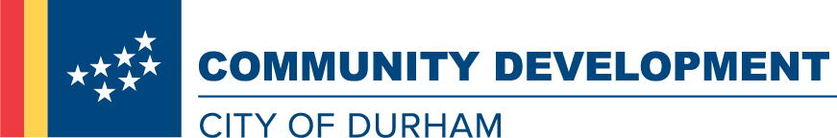
Position Description

Work, Serve, Thrive. With the City of Durham
Advance in your career while making a real difference in the community you serve.
The Community Development Department promotes thriving, livable neighborhoods in Durham. We work with lenders, developers, builders, community organizations and residents to enhance the quality and availability of affordable housing. We empower low-income and first-time home buyers to secure and remain in housing. Our talented, creative and committed staff make this happen. If you share our commitment to quality affordable housing, collaborative work and serving our community, join our team!
Hiring Range: $42,373.50 - $49,569.00
Temporary Full-time w/Benefits
Duration of Assignment: 42 months
The Senior Code Enforcement Officer for the Neighborhood Stabilization Team provides project management for residential lead-based paint and Healthy Homes remediation construction activities for the Community Development Department. Responsibilities include preparing construction cost estimates, conducting pre-bid and pre-construction meetings, site inspections, preparation and approval of change orders and contractor payment requests, and providing on-site problem mediation and resolution for construction activities. The Senior Code Enforcement Officer reports to the Senior Community Development Analyst for the Lead Grant Program.
Duties/Responsibilities
- Conducts job site inspections of lead hazard reduction and other construction work to ensure compliance with NC Building Code, City Minimum Housing Code, Rehab Standards/Specifications, and U.S. Department of Housing and Urban Development (HUD), Environmental Protection Agency, Occupational Safety and Health Administration, and NC Division of Environment and Natural Resources Lead Hazard Control regulations.
- Prepares rehabilitation work write-ups specific for lead paint and Healthy Homes remediation and for additional rehab cases as needed.
- Conducts pre-bid and pre-construction meetings.
- Performs minimum housing code inspections, Healthy Homes assessments and visual lead assessments based on lead inspection and Healthy Homes reports.
- Prepares and approves change orders and partial payments.
- Prepares drawings and cost estimates for lead control and Healthy Homes construction work.
- Provides on-site problem mediation and resolution.
- Provides educational presentations to the general public about lead-based paint issues and other applicable topics.
- Performs all duties listed in the position description as well as other related duties as assigned.
Minimum Qualifications & Experience
- High School Diploma or GED
- 3 years of related construction experience
- Valid NC Class "C" Driver's license with a satisfactory driving record
- NC Building Inspector Level 1 Certificate
- NC Certified Lead Supervisor
Additional Preferred Skills
- NC Renovate, Repair, Paint, and Healthy Homes Specialist Certification
- Experience working with a HUD Lead-Based Paint Grant Program.
- Excellent customer service skills and demonstrates ability to work in diverse communities with a variety of community residents.
- Strong oral and written communication skills
- Strong organization skills
- Excellent computer skills, including competency in use of Microsoft Word, Excel, and PowerPoint.
Agency
City of Durham
Address
101 City Hall Plaza
Durham, North Carolina, 27701
Website
http://agency.governmentjobs.com/durhamnc

